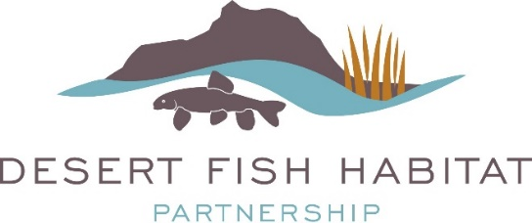

FY2024 DFHP Project Funding Opportunity
November 28, 2022 – February 24, 2023

The Desert Fish Habitat Partnership (DFHP) is proud to announce our FY2024 Request for Project Proposals. As one of 20 federally recognized National Fish Habitat Partnerships, DFHP is a collaborative effort between 11 western states, federal agencies, sovereign tribes, non-governmental organizations, and private conservation groups that seek to cooperatively conserve native desert fish species across their historic ranges by protecting, restoring, and enhancing aquatic ecosystems. Project funding is made available to grantees annually through the National Fish Habitat Partnership (NFHP) Board.

Eligible Projects: Projects considered for funding address science-based habitat protection, restoration, and enhancement activities that benefit native desert fish species addressed by DFHP (for a complete species list, visit the DFHP Strategic Plan). Types of eligible projects may include riparian or instream habitat protection, enhancement, and restoration; barrier removal or construction; range-wide population or watershed habitat assessments to prioritize and plan habitat conservation; and habitat-related community outreach and education actions.

NFHP funds must be used for on-the-ground habitat projects, related project design and monitoring activities, habitat assessments, educational and outreach activities, or acquisition of real property. Funds may not be used for research projects. Funded projects must be completed within 18-36 months of receipt of contract agreement, and multi-year projects MUST be broken into distinct phases by year for tasks, accomplishments, and budget.

DFHP’s Focal Area: Up to 75% of DFHP’s NFHP funding may be allocated to a specific DFHP geographic region rotating on an annual basis, starting with Basin and Range, and followed by the Lower Colorado, Upper Colorado, and Rio Grande (see map below delineating geographic region boundaries). It is not guaranteed that a full 75% of NFHP funds must be allocated to projects within the focal geographic region of that year and project submissions from all geographic regions are welcomed and encouraged. Proposals will be continued to be judged on merit, first and foremost.
- FY2021 – Basin and Range
- FY2022 – Lower Colorado
- FY2023 – Upper Colorado
- FY2024 – Rio Grande

Available Funding: The America’s Conservation Enhancement Act authorizes an appropriation of $7.2 million in NFHP funds for FY2024 projects. However, the exact amount of funding available to DFHP varies annually and is not known at this time. This is a very competitive process and we anticipate our pool of applicants to exceed available funding. Typical funding per project is within the range of $5k-$50k; however, proposals requesting over $50k are still welcome and considered. There is a 1:1 non-Federal match requirement, which may include cash and/or in-kind labor, materials, or equipment if there are no federal ties to those funds. Special consideration will be given to projects with more than the minimum non-federal match. The DFHP Steering Committee will review and rank applications based on their ability to meet the partnership’s key priorities and strategic objectives (see the DFHP Strategic Plan).

NFHP funds are federal funds, administered through the U.S. Fish and Wildlife Service (USFWS). All organizations that receive NFHP funding are required to complete all requirements for federal grants, including registration on the federal System for Award Management (SAM.org), Automated Standard Application for Payments (ASAP), Grants Solutions grant management system, and provide interim and annual reports to the USFWS and DFHP. NFHP funds are processed through a grant agreement completed through the USFWS Regional Offices or local Fish and Wildlife Conservation Office (FWCO). Grants are paid on a reimbursable basis. All federal funding requires environmental compliance documents (Federal Assistance Biological Assistance/ Endangered Species Act Evaluation Form, National Environmental Policy Act Exclusion and National Historic Preservation Act Form) to be
approved prior to execution of a grant agreement. DFHP also requires the timely provision of copies of final reports with before/after project photos to DFHP.
Anticipated Timeline:
Nov 2022-Feb 2023 Develop project proposals for funding consideration
Feb 24, 2023 Project Proposals Due
Feb-Dec 2023 Proposals evaluated by DFHP Steering Committee, NFHP, DOI
Jan-May 2024 Announcement of awards to recipients (dependent on Congress appropriation)
Jun-Sept 2024 Agreements processed/funds awarded

Contact Information: Please contact DFHP coordinator, Jennifer Graves, with any questions. Below are DFHP’s Regional Representatives who can also answer questions and assist with the process. Submit completed proposals in a single PDF format to the DFHP coordinator, Jennifer Graves, at Jennifer_m_graves@fws.gov.
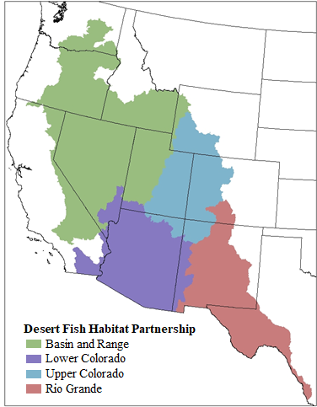
Regional Representatives
Basin and Range
Chris Crookshanks (NDOW)
ccrookshanks@ndow.org
(775) 688-1530

Lower Colorado River including the Rio Yaqui, Rio de la Conception, and Rio Sonoyta
Brandon Senger (NDOW)
bsenger@ndow.org
(702) 668-3999

Upper Colorado River
Tom Fresques (BLM)

t1fresqu@blm.gov
(970) 876-9078

Rio Grande including Pecos River and Tularosa Basin
Megan Bean (TPWD)
Megan.Bean@tpwd.state.tx.us
(512) 389-4303

Applications are due by 5:00 p.m. Pacific Time on Friday February 24, 2023.
The Cover Sheet and all application related documentation with specific guidance for completing the application is available on the DFHP website. Late or incomplete applications will only be considered under special circumstances, such as if on time applications do not meet anticipated funding levels.

