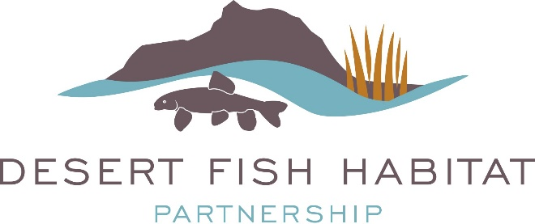

2020 DFHP Project Funding Opportunity
July 1, 2019 - Friday September 27, 2019

Funding for habitat projects through the National Fish Habitat Board and U.S. Fish and Wildlife Service (USFWS) is expected Summer-Fall 2020. Successful applicants will be notified after funding is allotted.
The Desert Fish Habitat Partnership (DFHP) is proud to announce our 2020 request for project proposals. As one of 20 federally recognized National Fish Habitat Partnerships, DFHP is a collaborative effort between 11 western states, federal agencies, sovereign tribes, and private conservation groups that seek to cooperatively conserve native desert fish species across their historic ranges by protecting, restoring, and enhancing aquatic ecosystems. Project funding is made available to grantees annually through the National Fish Habitat Partnership (NFHP) and the U.S. FWS.

Eligible Projects: Projects considered for funding address science-based habitat protection, restoration, and enhancement activities that benefit desert native fish species addressed by DFHP (for a complete species list, visit the DFHP Strategic Plan). Eligible projects include riparian or instream habitat protection, enhancement, and restoration. Examples are: barrier removal or construction; range-wide population or watershed habitat assessments to prioritize and plan habitat conservation.

NFHP funds must be used for on-the-ground habitat projects and related project design and monitoring activities. Funds may not be used for mitigation work or research. Funded projects must be completed within 18-36 months of receipt of contract agreement, and multi-year projects must be broken into distinct phases by year for tasks, accomplishments, and budget.

Available Funding: DFHP anticipates receiving between $50,000 and $150,000 in NFHP funds for FY 2020 projects. However, the exact amount of funding available to the partnership varies annually and is not known at this time. This is a very competitive process and we anticipate our applicant requests will exceed available funding. Project requests should be within the range of $5K-$50K. Successful proposals demonstrate a minimum 1 federal: 1 non-federal match, which may include cash, time, materials, or other services. Special consideration will be given to projects with more than the minimum non-federal match.

The DFHP Executive Committee will review and rank applications based on their ability to meet the partnership’s key priorities and strategic objectives.

All projects that receive NFHP funding are required to provide annual reports to the U.S. FWS and also to provide timely progress and completion reports with before/after project photos to DFHP.

Contact Information: Please consult with your Regional Representative (see below) prior to submitting your proposal. Regional Representatives will answer questions and assist with the process. Submit completed proposals in electronic format to the DFHP Coordinator Stephanie L. Vail-Muse at stephanie_vail-muse@fws.gov.

Regional Representatives

Lower Colorado River including the Rio Yaqui, Rio de la Conception, and Rio Sonoyta
Brandon Senger (NDOW)
bsenger@ndow.org
(702)486-6738

Upper Colorado River
Jay Thompson (BLM)
jmthomps@blm.gov
(303) 239-3724

Rio Grande including Pecos River and Tularosa Basin
Megan Bean (TPWD)
Megan.Bean@tpwd.state.tx.us
(512)389-4303

Basin and Range
Jon Sjoberg (NDOW)
sjoberg@ndow.org
(775) 688-1533

Applications are due by Friday September 27, 2019

The Cover Sheet and all application related documentation with specific guidance for completing the application is available on the DFHP website (www.desertfhp.org). Late or incomplete applications will be not accepted.

Stephanie L. Vail-Muse, DFHP Coordinator Desert Fish Habitat Partnership
918-457-7575
928-338-4288 ext. 26185
stephanie_vail-muse@fws.gov

