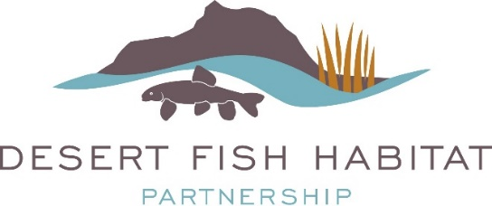

FY2021 DFHP Project Funding Opportunity
June 1, 2020 – September 25, 2020

Funding for habitat projects through the National Fish Habitat Partnership and U.S. Fish and Wildlife Service is expected Spring – Summer 2021. Successful applicants will be notified after funding is allotted.

The Desert Fish Habitat Partnership (DFHP) is proud to announce our FY2021 Request for Project Proposals. As one of 20 federally recognized National Fish Habitat Partnerships, DFHP is a collaborative effort between 11 western states, federal agencies, sovereign tribes, and private conservation groups that seek to cooperatively conserve native desert fish species across their historic ranges by protecting, restoring, and enhancing aquatic ecosystems. Project funding is made available to grantees annually through the National Fish Habitat Partnership (NFHP) and the U.S. Fish and Wildlife Service (USFWS).

Eligible Projects: Projects considered for funding address science-based habitat protection, restoration, and enhancement activities that benefit native desert fish species addressed by DFHP (for a complete species list, visit the DFHP Strategic Plan). Types of eligible projects may include riparian or instream habitat protection, enhancement, and restoration; barrier removal or construction; range-wide population or watershed habitat assessments to prioritize and plan habitat conservation; and habitat-related community outreach and education actions.

NFHP funds must be used for on-the-ground habitat projects and related project design and monitoring activities. Funds may not be used for acquisition in fee or easement, or research. Funded projects must be completed within 18-36 months of receipt of contract agreement, and multi-year projects MUST be broken into distinct phases by year for tasks, accomplishments, and budget.

DFHP’s Focal Area: Up to 75% of DFHP’s NFHP funding may be allocated to a specific DFHP geographic region rotating on an annual basis, starting with Basin and Range, and followed by the Lower Colorado, Upper Colorado, and Rio Grande (see map below delineating geographic region boundaries). It is not guaranteed that a full 75% of NFHP funds must be allocated to projects within the focal geographic region of that year and project submissions from all geographic regions are welcomed and encouraged. Proposals will be continued to be judged on merit, first and foremost.
- FY2021 – Basin and Range
- FY2022 – Lower Colorado
- FY2023 – Upper Colorado
- FY2024 – Rio Grande

Available Funding: DFHP anticipates receiving between $100,000 and $200,000 in NFHP funds for FY2021 projects. However, the exact amount of funding available to the partnership varies annually and is not known at this time. This is a very competitive process and we anticipate our pool of applicants to exceed available funding. Typical funding per project is within the range of $5K-$50K. Successful proposals demonstrate a minimum 1 federal: 1 non-federal match, which may include cash, time, materials, or other services. Special consideration will be given to projects with more than the minimum non-federal match. The DFHP Executive Committee will review and rank applications based on their ability to meet the partnership’s key priorities and strategic objectives (see the DFHP Strategic Plan).

All projects that receive NFHP funding are required to provide interim and/or final reports to the USFWS as outlined in the appropriate grant award. Additionally, timely progress and completion reports with before/after project photos submitted to DFHP are required.

DFHP anticipates notifying successful applicants on funding allocations and initiating the grant award process around April – June, 2021.

Contact Information: Please consult with your Regional Representative (see below) prior to submitting your proposal. Regional Representatives will answer questions and assist with the process. Please feel free to also contact DFHP Coordinator, Jennifer Graves, with any questions. Submit completed proposals in a single PDF format to the DFHP Coordinator, Jennifer Graves, at jennifer_m_graves@fws.gov.
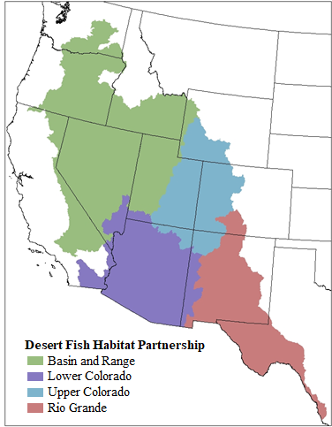

Regional Representatives
Basin and Range
Jon Sjöberg (NDOW)
sjoberg@ndow.org
(775) 688-1530

Lower Colorado River including the Rio Yaqui, Rio de la Conception, and Rio Sonoyta
Brandon Senger (NDOW)
bsenger@ndow.org
(702) 668-3999

Upper Colorado River
Jay Thompson (BLM)
jmthomps@blm.gov
(303) 239-3724

Rio Grande including Pecos River and Tularosa Basin
Megan Bean (TPWD)
Megan.Bean@tpwd.state.tx.us
(512) 389-4303

Applications are due by 5:00 p.m. Pacific Time on Friday September 25, 2020.

The Cover Sheet and all application related documentation with specific guidance for completing the application is available on the DFHP website. Late or incomplete applications will only be considered under special circumstances, such as if on time applications do not meet anticipated funding levels.

Jennifer Graves, Desert Fish Habitat Partnership Coordinator
(o): 928-338-4288 ext. 26185
(c): 860-268-9789

jennifer_m_graves@fws.gov

